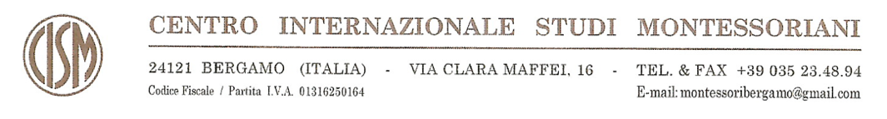

ART WEBINAR APPLICATION FORM

Name and surname:
(family name in block letters)
Address:
Phone number:
Email:
Profession / Employment:
AMI 6-12 diploma number:
For which series you are applying: Series 1; Series 2; both series? _____________________________

I certify that all the information and answers herein are complete and I agree with personal data processing.

Date  _____________________________ |  | Signature  ___________________________

Documents required for enrolment:
- Application form duly filled in and signed
- Copy of your ID or passport
- Copy of your AMI 6-12 diploma.
Please send the above documents in an electronic format to montessoribergamo@gmail.com.
You will receive the confirmation of enrolment shortly.

